1. To Print these Pyramids (using switch case): -

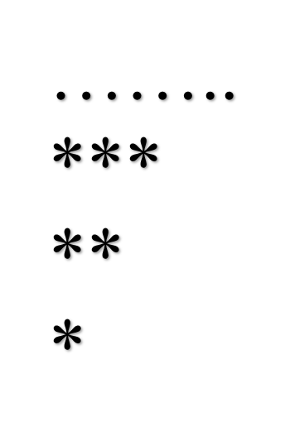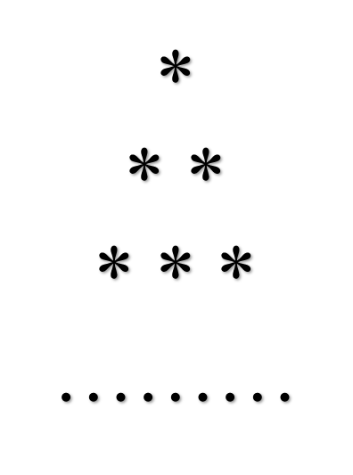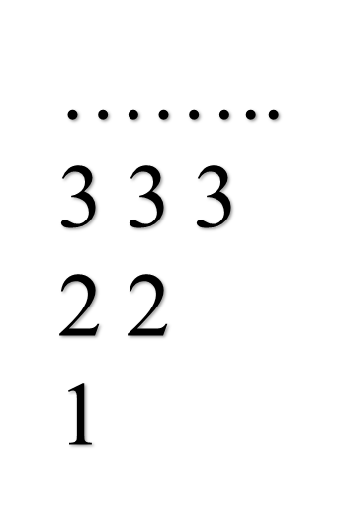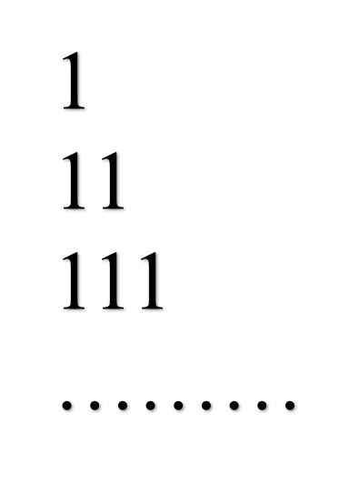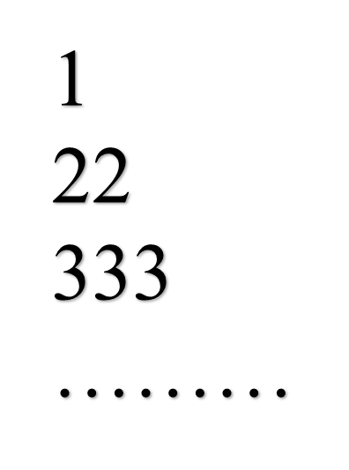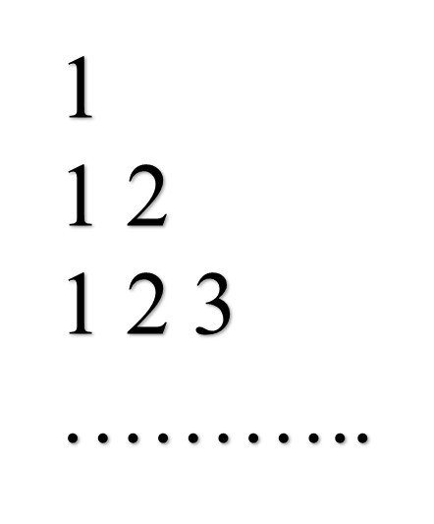

#include<stdio.h>

#include<conio.h>

int main()

{

int option;

printf("Enter your option\n");

scanf("%d",&option);

switch(option)

{

case 1:

{

int i,j,k,n;

printf("How many times do you want to print?\n");

scanf("%d",&n);

printf("\n");

for(i=1; i<=n; i++)

{

for (k=n; k>=i; k--)

printf(" ");

for (j=1; j<=i; j++)

printf("* ");

printf("\n");

}

break;

}

case 2:

{

int i,j,n;

printf("How many times do you want to print?\n");

scanf("%d",&n);

printf("\n");

for(i=1; i<=n; i++)

{

for (j=1; j<=i; j++)

printf("%d",j);

printf("\n");

}

break;

}

case 3:

{

int i,j,n;

printf("How many times do you want to print?\n");

scanf("%d",&n);

printf("\n");

for(i=1; i<=n; i++)

{

for (j=1; j<=i; j++)

printf("%d",i);

printf("\n");

}

break;

}

case 4:

{

int i,j,n;

printf("How many times do you want to print?\n");

scanf("%d",&n);

printf("\n");

for(i=1; i<=n; i++)

{

for (j=1; j<=i; j++)

printf("1 ");

printf("\n");

}

break;

}

case 5:

{

int i,j,n;

printf("How many times do you want to print?\n");

scanf("%d",&n);

printf("\n");

for(i=n; i>=1; i--)

{

for (j=1; j<=i; j++)

printf("%d ",i);

printf("\n");

}

break;

}

case 6:

{

int i,j,n;

printf("How many times do you want to print?\n");

scanf("%d",&n);

printf("\n");

for(i=n; i>=1; i--)

{

for (j=1; j<=i; j++)

printf("*");

printf("\n");

}

break;

default:

printf("Please Enter a value between 1 to 6");

}

return 0;

}

getch();

}